**TASK 1**

**Name:** SWETHAM

**Rollno:** 22CSR217

**Step 1:** Login to the Jenkins page and create a Nginx item by using the new item in the dashboard after that give the description by writing the commands.

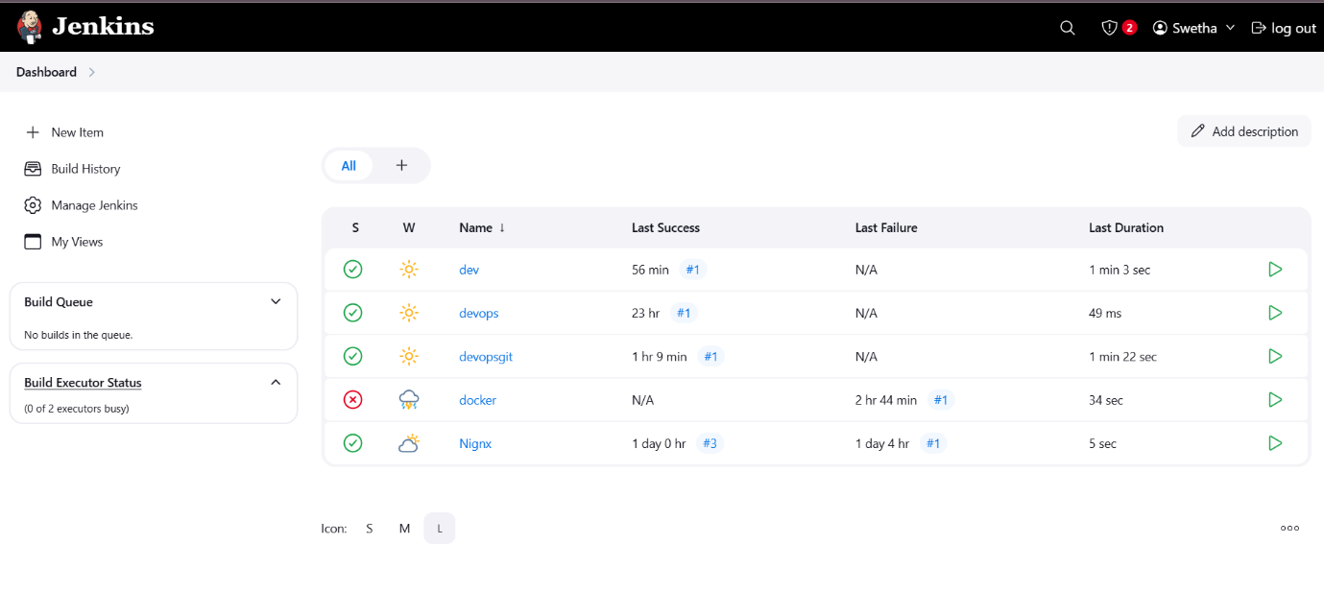

**Step 2:** After the commands given give save and apply and then give build now

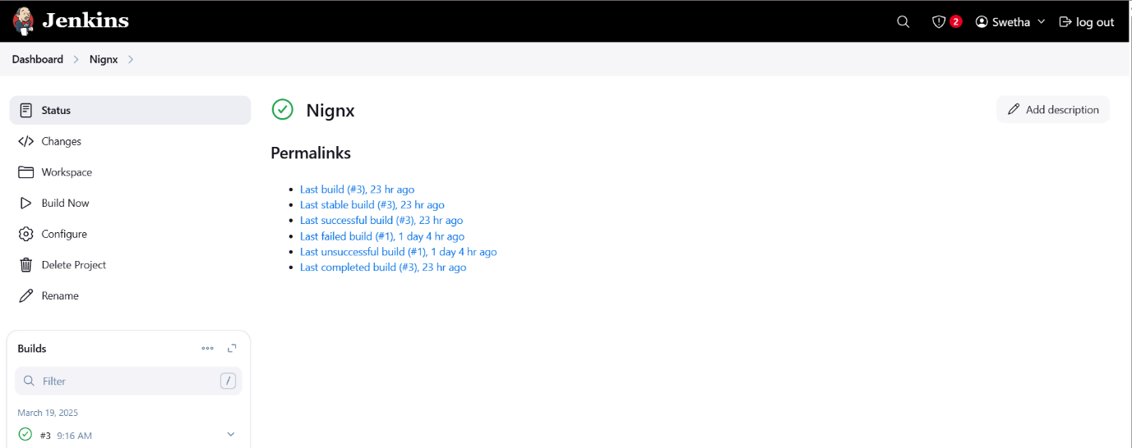

**Step 3**: Verify the output in console output: